Review: Centripetal Force
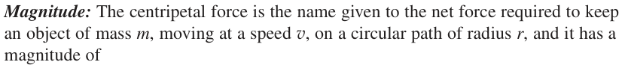
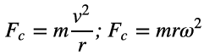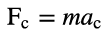

Review: Centripetal Acceleration
Magnitude: $a_{c}=\frac{v^{2}}{r}, or a_{c}=rω^{2}$. Direction of $a_{c}$ : always points toward the center of the circle.

Banked Curves
When a car travels without skidding around an unbanked curve, the static frictional force between the tires and the road provides the centripetal force. Draw FBD of a car making a turn on a level road, the radius of the turn is r, coefficient of static friction is $μ_{s}$. Indicate $F_{c}=f_{s}$ and write $μ_{s}$ in terms of $r, v, and g.$

However, if the curve is banked at an angle relative to the horizontal, much in the same way that a plane is banked while making a turn.
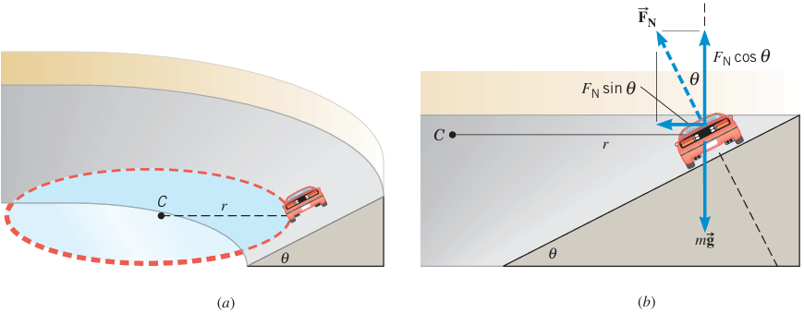
Centripetal force is the net force along the direction of radius (radial direction). What forces provide the centripetal force in the diagram (b) above?

Centripetal force on the car on a banked curve:
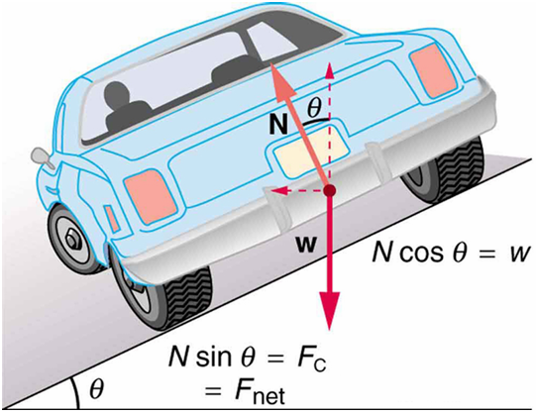

Example 1
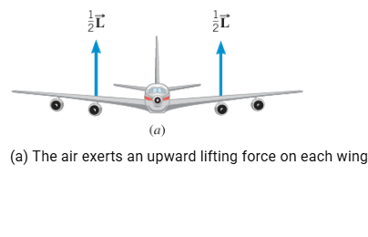 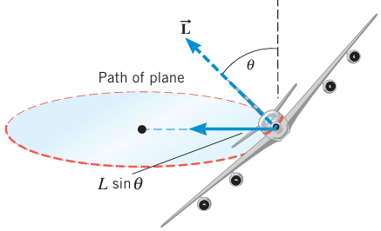(b)l
(b) What forces provide the centripetal force when the plane is making a turn? Write the speed of the plane v in terms of the lifting force L, mass of the plane m, the radius of turning circle R, and the turning angle $θ$.

29. A jet flying at 123 m/s banks to make a horizontal circular turn. The radius of the turn is 3810 m, and the mass of the jet is 200000kg. Calculate the magnitude of the necessary lifting force.

24. On a banked race track, the smallest circular path on which cars can move has a radius of 112 m, while the largest has a radius of 165 m, as the drawing illustrates. The height of the outer wall is 18 m. Find (a) the smallest and (b) the largest speed at which cars can move on this track without relying on friction.
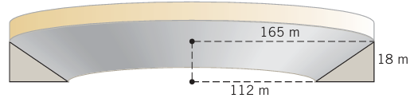

Practice problems: Free Body Diagram for Circular Motion

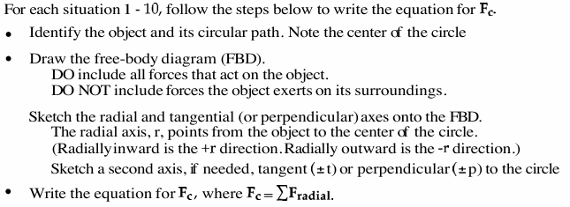
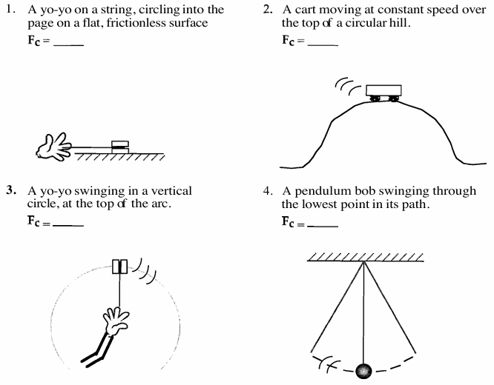
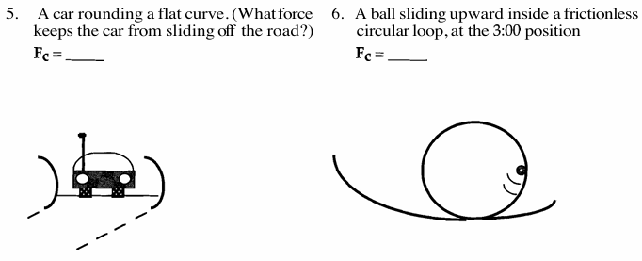
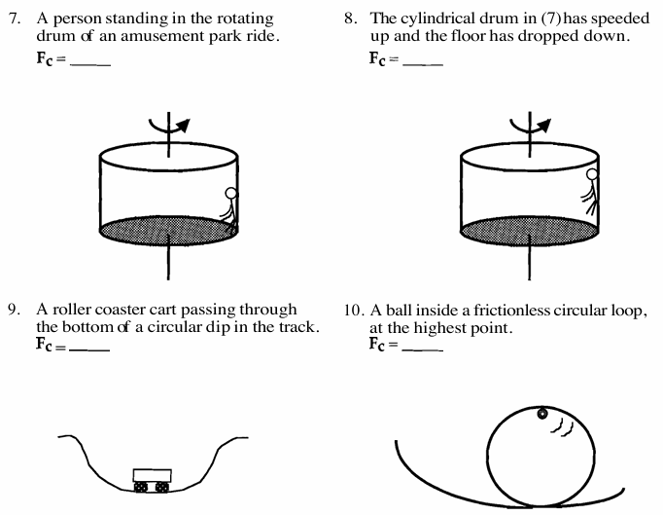

14. At an amusement park, there is a ride in which cylindrically shaped chambers spin around a central axis. People sit in seats facing the axis, their backs against the outer wall. At one instant the outer wall moves at a speed of 3.2 m/s, and an 83-kg person feels a 560-N force pressing against his back. What is the radius of the chamber?

19. A 9.5-kg monkey is hanging by one arm from a branch and is swinging on a vertical circle. As an approximation, assume a radial distance of 85 cm between the branch and the point where the monkey’s mass is located. As the monkey swings through the lowest point on the circle, it has a speed of 2.8 m/s. Find (a) The magnitude of the centripetal force acting on the monkey;
(b) The magnitude of the tension in the monkey’s arm.

